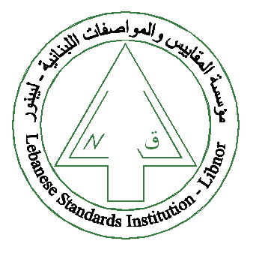
The Lebanese Standards Institution
Invites you to attend the

“ISO9001 Introductory”
Training course

Offered by LIBNOR training centre


Date: 26-27 April 2017
Time: 9:00am -16:00pm
Location: LIBNOR training centre
For more enquiries about the training sessions and registration kindly contact our training centre
- At the following email address: caboujaoude@libnor.org
- By calling us: 01-485927 ext:163

